**Assignment 1 HTML**

**Princess Blessing Nkonda Kuenzob**

**INFO1247**

**Andrai Vanezi**

**6/22/2025**

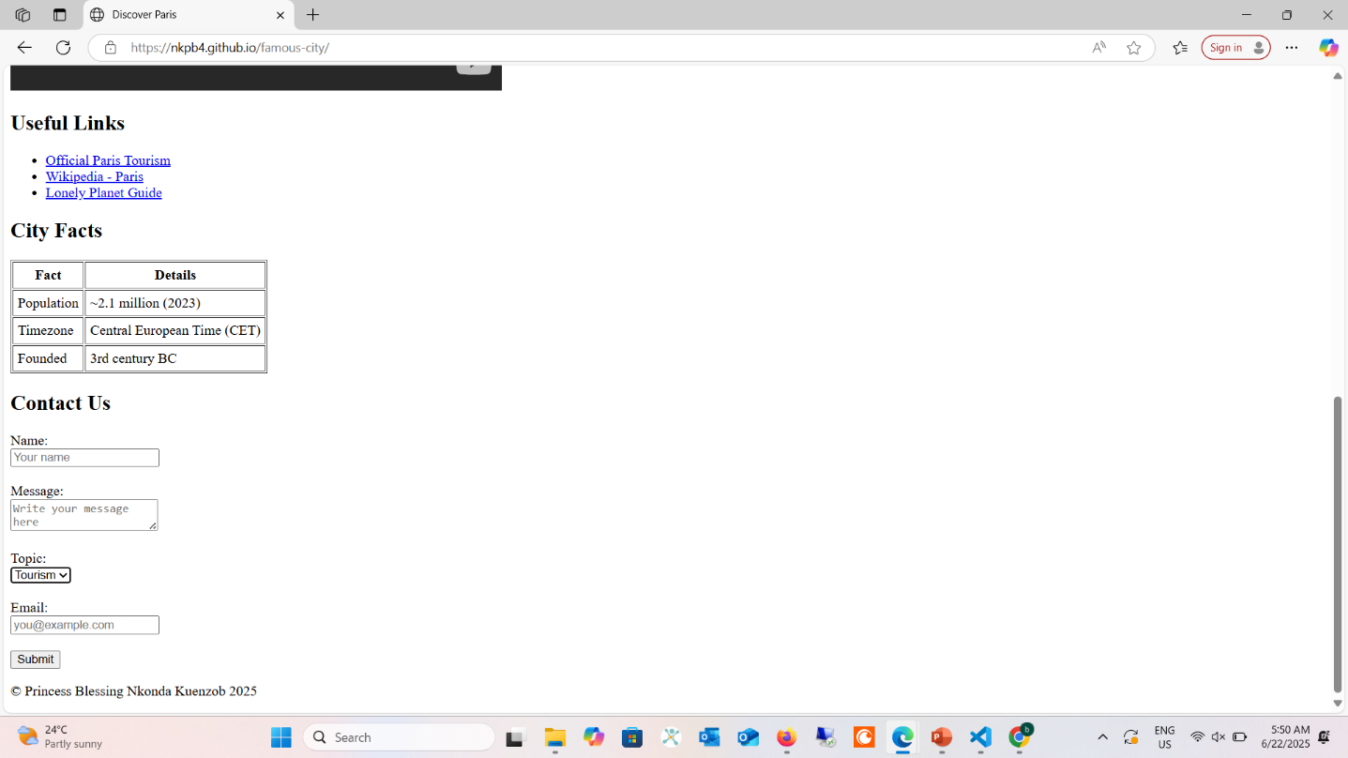

URL :<https://nkpb4.github.io/famous-city/>